Lab sheet – answers

Programming

Name – Hiba Bazarath

1. **START**

INPUT: num1 , num 2 , num3

IF (num1 > num2 ) AND (num1 > num3 ) THEN

DISPLAY “the largest number is ” + num1

ELSE IF (num2 > num1 ) AND (num2 > num3) THEN

DISPLAY “the largest number is ” + num2

ELSE

DISPLAY “the largest number is ” + num3

END IF

**END**

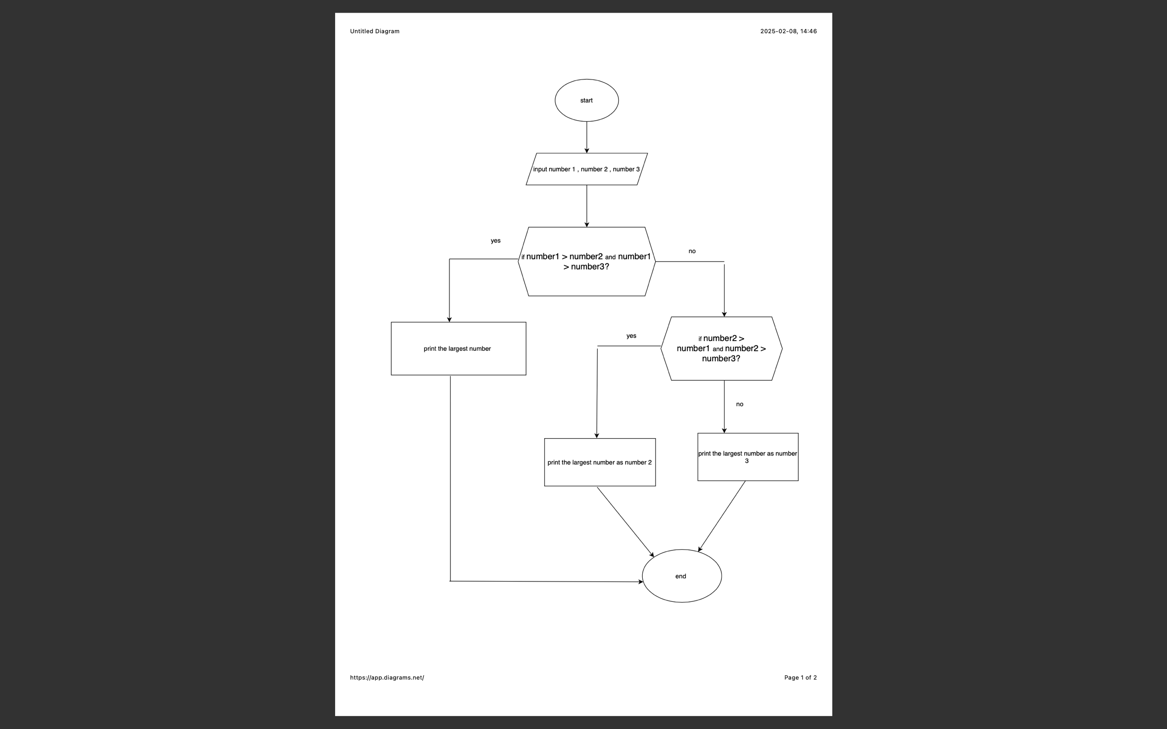

1. **START**

INPUT: factorial (n)

IF n<0 THEN RETRUN “Invalid point”

IF n=0 or n=1 THEN RETURN 1

SET result to 1

FOR each value from 2 to number

Multiply result by the value and store it in result

RETURN result

END FUNCTION

PRINT "Enter a number: "

READ number

answer ← Factorial(number)

PRINT "Factorial of ", number, " is ", answer

**END**

1. **START**

PRINT "Enter a number: "

READ n IF n < 2 THEN

PRINT "Not Prime"

STOP

END IF

SET isPrime ← true

FOR i FROM 2 TO sqrt(n) DO

IF n MOD i = 0 THEN

SET isPrime ← false

BREAK END IF END FOR

SET isPrime ← false

BREAK

END IF

END FOR

PRINT "Prime" IF isPrime ELSE PRINT "Not Prime"

END

1. **START**

INPUT : hourly pay rate FROM user

INPUT: hours worked FROM user

IF hoursWorked <= 40 THEN

regularPay = hourlyPayRate * hoursWorked

overtimePay = 0

ELSE

regularPay = hourlyPayRate * 40

overtimeHours = hoursWorked - 40

overtimePay = overtimeHours * (hourlyPayRate * 1.5)

ENDIF

grossPay = regularPay + overtimePay

OUTPUT "Regular Pay: ", regularPay

OUTPUT "Overtime Pay: ", overtimePay

OUTPUT "Gross Pay: ", grossPay

**END**

1. 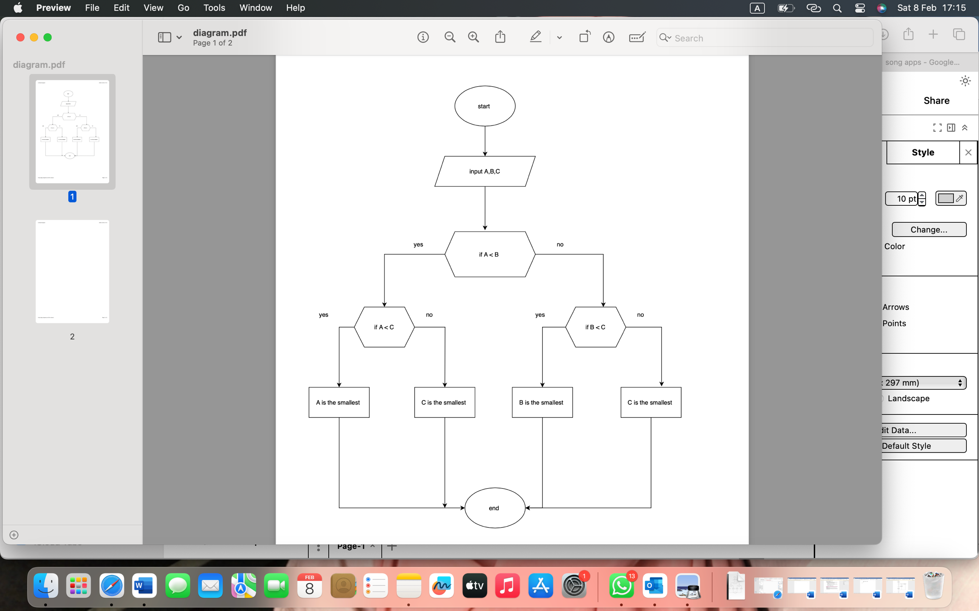
2. 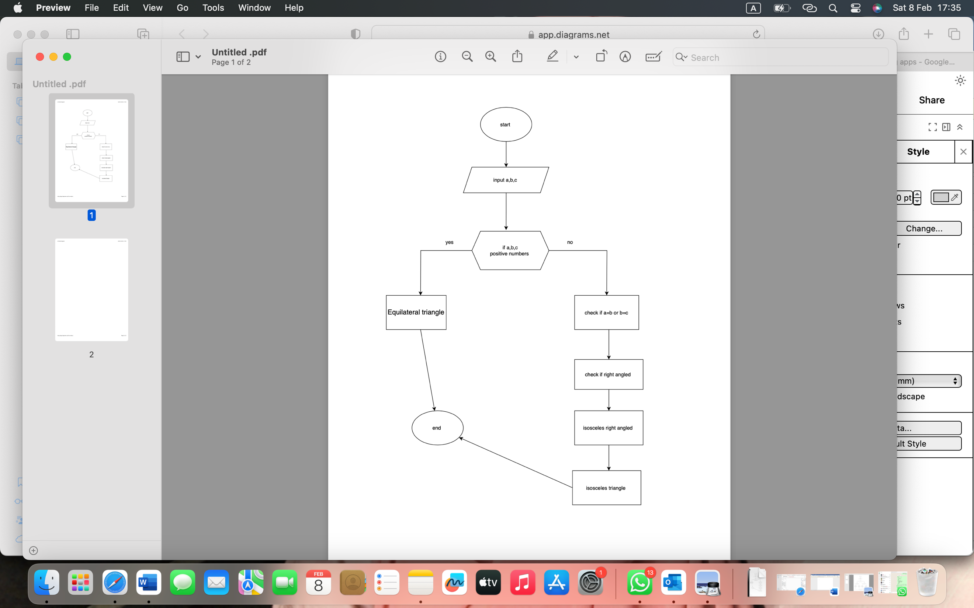
3. **START**

PRINT “enter a year : ”

READ year

IF (year % 400 = 0) THEN

PRINT “leap year”

ELSE IF (year % 4 = 0 AND year % 100 1=0) THEN

PRINT “leap year”

ELSE

PRINT “not a leap year”

**END**